Simulation-Based Electromagnetic Analysis of TEM, TE and TM Propagation Modes in Microwave Transmission Structures
Aim:
To simulate and analyze the electromagnetic field distribution and propagation characteristics of TEM, TE, and TM modes in microwave transmission structures.
Procedure:
- Open the electromagnetic simulation software, such as MATLAB or CST Studio Suite.
- Select a suitable microwave transmission structure, such as a waveguide or coaxial cable.
- Define the structure dimensions, operating frequency, and material properties.
- Simulate the TEM, TE, and TM propagation modes and observe their electric and magnetic field distributions.
- Analyze the propagation characteristics and compare the results of the three modes.
Code:
clc;
clear;
close all;
%% =========================================================
% ELECTROMAGNETIC MODE ANALYSIS OF RECTANGULAR WAVEGUIDE
% TE10 AND TM11 MODES
% ==========================================================
%% Input Parameters
c = 3e8; % Speed of light (m/s)
f = 10e9; % Operating frequency (Hz)
a = 22.86e-3; % Width (m)
b = 10.16e-3; % Height (m)
L = 100e-3; % Waveguide length (m)
fprintf('\n============================================\n');
fprintf(' RECTANGULAR WAVEGUIDE MODE ANALYSIS\n');
fprintf('============================================\n');
fprintf('Operating Frequency : %.2f GHz\n',f/1e9);
fprintf('Waveguide Width : %.2f mm\n',a*1000);
fprintf('Waveguide Height : %.2f mm\n',b*1000);
fprintf('Waveguide Length : %.2f mm\n',L*1000);
%% =========================================================
% TE10 MODE
% ==========================================================
m1 = 1;
n1 = 0;
fc_TE10 = (c/2)*sqrt((m1/a)^2+(n1/b)^2);
k0 = 2*pi*f/c;
if f >= fc_TE10
beta_TE10 = sqrt(k0^2-(2*pi*fc_TE10/c)^2);
lambda_g = 2*pi/beta_TE10;
TE10_status = 'PROPAGATING';
else
beta_TE10 = 0;
lambda_g = Inf;
TE10_status = 'CUT OFF';
end
%% =========================================================
% TM11 MODE
% ==========================================================
m2 = 1;
n2 = 1;
fc_TM11 = (c/2)*sqrt((m2/a)^2+(n2/b)^2);
if f >= fc_TM11
beta_TM11 = sqrt(k0^2-(2*pi*fc_TM11/c)^2);
TM11_status = 'PROPAGATING';
else
alpha_TM11 = sqrt((2*pi*fc_TM11/c)^2-k0^2);
beta_TM11 = 0;
TM11_status = 'CUT OFF / EVANESCENT';
end
%% =========================================================
% DISPLAY RESULTS
% ==========================================================
fprintf('\n--------------------------------------------\n');
fprintf('TE10 MODE RESULTS\n');
fprintf('--------------------------------------------\n');
fprintf('Cutoff Frequency : %.3f GHz\n',fc_TE10/1e9);
fprintf('Propagation Constant : %.3f rad/m\n',beta_TE10);
fprintf('Guide Wavelength : %.3f mm\n',lambda_g*1000);
fprintf('Mode Status : %s\n',TE10_status);
fprintf('\n--------------------------------------------\n');
fprintf('TM11 MODE RESULTS\n');
fprintf('--------------------------------------------\n');
fprintf('Cutoff Frequency : %.3f GHz\n',fc_TM11/1e9);
fprintf('Mode Status : %s\n',TM11_status);
if f < fc_TM11
fprintf('Attenuation Constant : %.3f Np/m\n',alpha_TM11);
end
%% =========================================================
% FIELD GRID
% ==========================================================
Nx = 150;
Ny = 100;
x = linspace(0,a,Nx);
y = linspace(0,b,Ny);
[X,Y] = meshgrid(x,y);
%% =========================================================
% TE10 ELECTRIC FIELD
% ==========================================================
E_TE10 = sin(pi*X/a);
figure;
imagesc(x*1000,y*1000,E_TE10);
axis xy;
axis equal tight;
colorbar;
xlabel('x (mm)');
ylabel('y (mm)');
title('TE_{10} Electric Field Distribution');
%% =========================================================
% TE10 MAGNETIC FIELD
% ==========================================================
H_TE10 = cos(pi*X/a);
figure;
imagesc(x*1000,y*1000,H_TE10);
axis xy;
axis equal tight;
colorbar;
xlabel('x (mm)');
ylabel('y (mm)');
title('TE_{10} Magnetic Field Distribution');
%% =========================================================
% TM11 ELECTRIC FIELD
% ==========================================================
E_TM11 = sin(pi*X/a).*sin(pi*Y/b);
figure;
imagesc(x*1000,y*1000,E_TM11);
axis xy;
axis equal tight;
colorbar;
xlabel('x (mm)');
ylabel('y (mm)');
title('TM_{11} Electric Field Distribution');
%% =========================================================
% TM11 MAGNETIC FIELD
% ==========================================================
H_TM11 = cos(pi*X/a).*cos(pi*Y/b);
figure;
imagesc(x*1000,y*1000,H_TM11);
axis xy;
axis equal tight;
colorbar;
xlabel('x (mm)');
ylabel('y (mm)');
title('TM_{11} Magnetic Field Distribution');
%% =========================================================
% FIELD PROPAGATION ALONG WAVEGUIDE
% =========================================================
z = linspace(0,L,300);
% TE10 propagating field
TE10_wave = cos(beta_TE10*z);
figure;
plot(z*1000,TE10_wave,'LineWidth',2);
grid on;
xlabel('Waveguide Length (mm)');
ylabel('Normalized Field');
title('TE_{10} Propagation Along Waveguide');
%% =========================================================
% TM11 EVANESCENT FIELD
% ==========================================================
if f < fc_TM11
TM11_wave = exp(-alpha_TM11*z);
figure;
plot(z*1000,TM11_wave,'LineWidth',2);
grid on;
xlabel('Waveguide Length (mm)');
ylabel('Normalized Field');
title('TM_{11} Evanescent Field');
end
%% =========================================================
% CUTOFF FREQUENCY COMPARISON
% ==========================================================
figure;
bar([fc_TE10 fc_TM11]/1e9);
set(gca,'XTickLabel',{'TE10','TM11'});
ylabel('Cutoff Frequency (GHz)');
xlabel('Mode');
title('Cutoff Frequency Comparison');
grid on;
%% =========================================================
% OPERATING FREQUENCY COMPARISON
% ==========================================================
figure;
bar([f fc_TE10 fc_TM11]/1e9);
set(gca,'XTickLabel', ...
{'Operating Frequency','TE10 Cutoff','TM11 Cutoff'});
ylabel('Frequency (GHz)');
title('Operating Frequency and Cutoff Frequencies');
grid on;
%% =========================================================
% FINAL RESULT
% ==========================================================
fprintf('\n============================================\n');
fprintf('FINAL OBSERVATION\n');
fprintf('============================================\n');
fprintf('At %.2f GHz:\n',f/1e9);
if f > fc_TE10
fprintf('TE10 : PROPAGATES\n');
else
fprintf('TE10 : DOES NOT PROPAGATE\n');
end
if f > fc_TM11
fprintf('TM11 : PROPAGATES\n');
else
fprintf('TM11 : DOES NOT PROPAGATE\n');
end
fprintf('\nTE10 is the dominant usable mode at 10 GHz.\n');
fprintf('TM11 is below cutoff and is therefore evanescent.\n');
fprintf('\nSimulation completed successfully.\n');
Output:
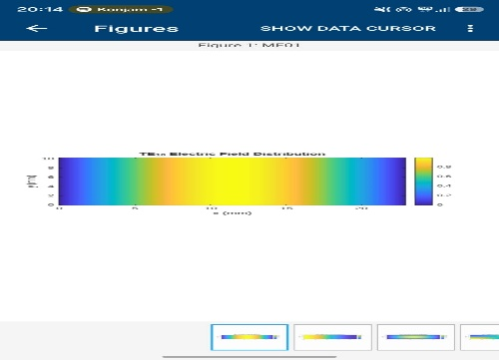 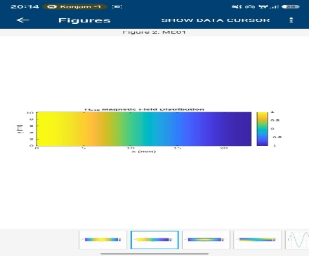 +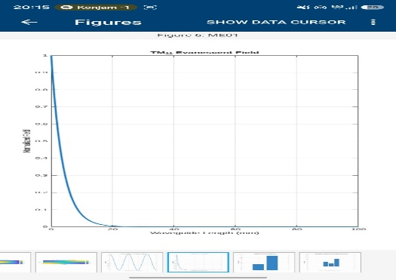 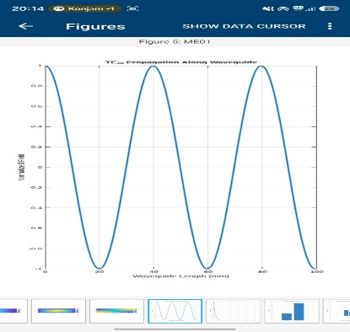
Result:
The TEM, TE, and TM propagation modes were simulated and analyzed successfully. Their electromagnetic field distributions and propagation characteristics were studied, and the differences between the three modes were identified.

